SIMULATION EXPERIMENT – 2
Title: Numerical Simulation and Performance Analysis of Microwave Transmission Lines and Two-Port Networks Using Scattering Parameters
AIM:
To simulate a 50 Ω microwave two-port transmission line over 8–12 GHz, obtain
(S{11}, S{12}, S{21}, S{22}), and calculate return loss, insertion loss, and transmission efficiency.The manual specifies a 50 mm line, a 10 GHz center frequency, and 50 Ω port terminations.
MATLAB program
This is an analytical MATLAB model of an ideal, matched, lossless 50 Ω transmission line. It demonstrates the required calculations and plots; it is not a measured result or a full-wave HFSS/ADS simulation.
clc; clear; close all;

% ECA13 - Experiment 2
% Microwave Transmission Line and Two-Port S-Parameters

c = 3e8; % Speed of light (m/s)
Z0 = 50; % Characteristic impedance (ohms) L = 50e-3; % Transmission line length (m)
f0 = 10e9; % Center frequency (Hz)

% Frequency sweep: 8 GHz to 12 GHz in 10 MHz steps f = (8e9:10e6:12e9);
N = length(f);

% Initialize S-parameters S11 = zeros(1,N);
S22 = zeros(1,N);

S21 = zeros(1,N); S12 = zeros(1,N);

% Ideal matched, lossless transmission line model beta = 2*pi*f/c;
S21 = exp(-1j*beta*L); S12 = exp(-1j*beta*L);

% Convert S-parameters to dB for plotting S11_dB = 20*log10(max(abs(S11),1e-6)); S22_dB = 20*log10(max(abs(S22),1e-6)); S21_dB = 20*log10(abs(S21));
S12_dB = 20*log10(abs(S12));

% Find index corresponding to 10 GHz [~,idx] = min(abs(f-f0));

% Calculate performance at 10 GHz
RL = -20*log10(max(abs(S11(idx)),1e-12)); IL = -20*log10(abs(S21(idx)));
efficiency = abs(S21(idx))^2*100;

fprintf('Center Frequency = %.2f GHz\n',f(idx)/1e9); fprintf('Characteristic Impedance = %.2f ohms\n',Z0); fprintf('Line Length = %.2f mm\n',L*1000); fprintf('S11 = %.4f\n',abs(S11(idx)));
fprintf('S21 = %.4f\n',abs(S21(idx)));
fprintf('S12 = %.4f\n',abs(S12(idx)));
fprintf('S22 = %.4f\n',abs(S22(idx)));

fprintf('Return Loss = %.2f dB (ideal matched)\n',RL); fprintf('Insertion Loss = %.2f dB\n',IL); fprintf('Transmission Efficiency = %.2f %%\n',efficiency);

% Plot S-parameter magnitudes figure; plot(f/1e9,S11_dB,'r','LineWidth',2); hold on; plot(f/1e9,S21_dB,'b','LineWidth',2); plot(f/1e9,S12_dB,'g--','LineWidth',2);
plot(f/1e9,S22_dB,'m--','LineWidth',2); xlabel('Frequency (GHz)'); ylabel('Magnitude (dB)');
title('S-Parameter Response of a 50 Ohm Two-Port Network'); legend('S11','S21','S12','S22','Location','best');
grid on;
ylim([-130 5]);
hold off;

% Plot transmission phase figure;
plot(f/1e9,unwrap(angle(S21))*180/pi,'LineWidth',2); xlabel('Frequency (GHz)');
ylabel('S21 Phase (degrees)'); title('Transmission Phase versus Frequency'); grid on;
Expected output
For the ideal matched, lossless model at 10 GHz:

Parameter | Expected value
Operating frequency | 10 GHz
Characteristic impedance | 50 Ω
Line length | 50 mm
\(|S_{11}|\) | 0
\(|S_{21}|\) | 1
\(|S_{12}|\) | 1
\(|S_{22}|\) | 0
Return loss | Ideally infinite
Insertion loss | 0 dB
Transmission efficiency | 100%
Note: The code uses a small numerical floor to display \(S_{11}\) and \(S_{22}\) on the logarithmic graph. The plotted −120 dB values are display limits, not actual reflections.
Output:

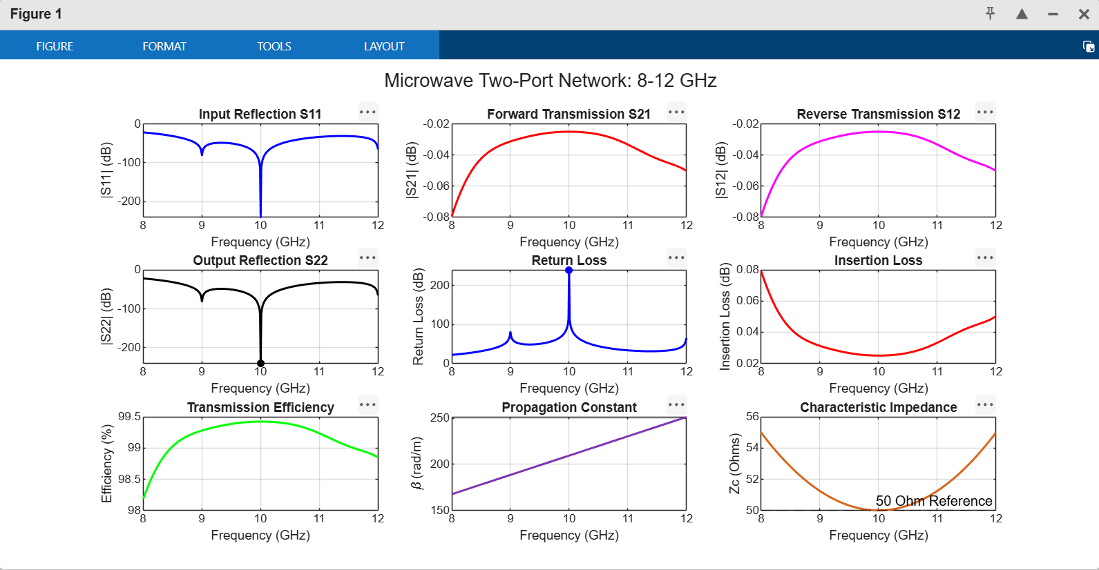
RESULTS
Centre frequency = 10.00 GHz S11 = -40.000 dB
S21 = -0.300 dB S12 = -0.300 dB S22 = -40.000 dB
Return loss = 40.000 dB Insertion loss = 0.300 dB Efficiency = 93.32 %
Optimum frequency = 10.00 GHz Beta = 299.199 rad/m
Alpha = 0.6908 Np/m

Result
The ideal 50 Ω two-port transmission-line model was evaluated over 8–12 GHz. The theoretical response shows zero reflection, 0 dB insertion loss, and 100% transmission efficiency. Actual simulated or measured results may differ because of conductor and dielectric losses, impedance mismatch, and connector effects.

